Word Endings

Learning word endings helps students to become better readers. Please practice these common endings with your child, to help them become more successful in learning new words they read in books.
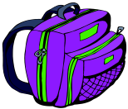 | 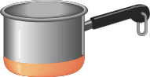 | 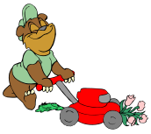 | 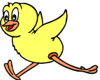 | 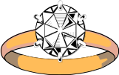 |  | 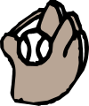
-ack  backpack  black  sack | -an  pan  ran  fan | -ow  mow  snow  slow | -ick  chick  stick  kick | -ing  ring  sing  sting | -op  stop  pop  hop | -it  mitt  bit  sit
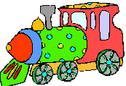 | 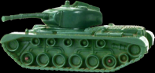 | 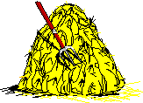 | 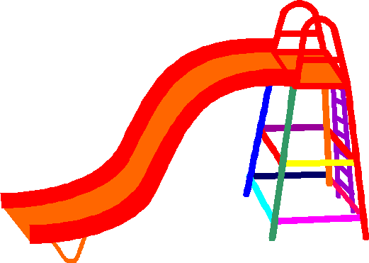 | 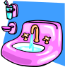 | 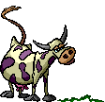 | 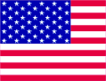
-ain  train  rain  brain | -ank  tank  bank  thank | -ay  day  play  spray | -ide  slide  hide  ride | -ink  sink  blink  pink | -ow  cow  how  now | -ag  flag  tag  bag
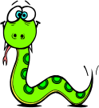 | 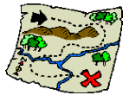 | 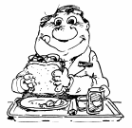 |  | 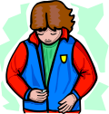 | 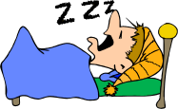 | 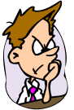
-ake  snake  make  take | -ap  map  clap  cap | -eat  seat  heat  meat | -ight  light  right  night | -ip  zip  drip  ship | -ore  snore  store  more | -ad  mad  sad  dad
 | 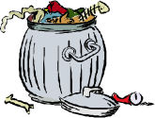 | 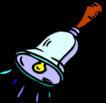 |  | 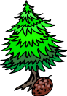 | 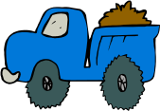 | 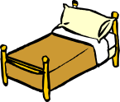
-ale  whale  male  sale | -ash  trash  crash  splash | -ell  bell  fell  shell | -ill  spill  will  hill | -ir  fir  stir  sir | -uck  truck  stuck  duck | -ed  bed  red  sled
 | 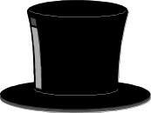 | 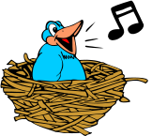 | 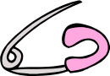 | 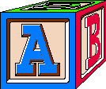 | 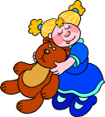 | 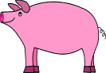
-all  ball  call  tall | -at  hat  bat  scat | -est  nest  vest  test | -in  pin  win  tin | -ock  block  clock  sock | -ug  hug  rug  bug | -ig  pig  dig  wig
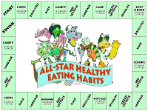 | 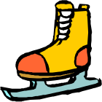 | 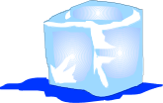 | 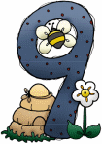 |  | 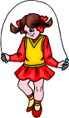 | 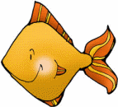
-ame  game  name  same | -ate  skate  late  gate | -ice  rice  slice  dice | -ine  nine  fine  line | -oke  joke  choke  stroke | -ump  jump  pump  stump | -ish  fish  wish  dish

